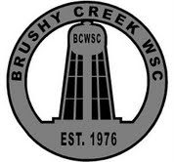
Brushy Creek Water Supply Corporation
P. O. Box 168 249 An Co Rd 432
Montalba, TX 75853-0168
903-549-2488 phone 903-549-2483 fax
www.brushycreekwsc.org
brushycreekwsc@gmail.com

For future reference, your bill is due upon receipt, past due after
the 15^{th.} If your account has a past due balance on the last
working day of the month, it will be locked on the 1st working
day of the following month. It is your responsibility to pay your
water bill. If you do not receive either a bill or email from us,
you need to call the office by the 1st week of the month, to find
out your amount due. Bills and emails are sent each month no
later than the last working day of the month. Late bills and emails
are sent on the 16th of the month. If your account is locked you
will incur $90.00 in trip charges.

